- What is distributed computing? explain it briefly
Distributed computing is a computing model in which a large computing task is divided into smaller tasks and distributed across multiple computers connected by a network. Each computer, known as a node, works on its assigned task independently, and then the results are combined to produce the final output.
The distributed computing model allows for parallel processing, which means that the workload can be completed faster than if it was processed on a single computer. It also provides fault tolerance, as if one node fails, the task can still be completed by the other nodes.
Distributed computing is used in a wide range of applications, including scientific research, data processing, and web applications. It enables organizations to leverage the computing power of multiple machines and provides a more efficient and scalable way to process large volumes of data.
Examples: 3D Graphics, Video Rendering, Complicated scientific Problems For these works single computer is not enough because its too slow to complete tasks, time consuming process. Distributed computing Concepts is large problem will devide into smaller unit and distribute to the number of computers, they will work as unicell and complete the tasks in less time.
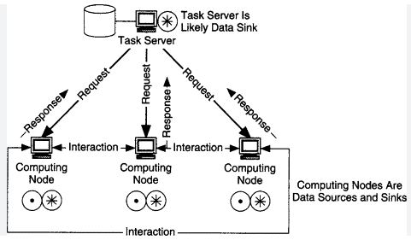
Advantages of distributed computing:
- Scalability: Distributed computing allows organizations to scale their computing resources as their needs grow, by adding more nodes to the network.
- Fault tolerance: Since the workload is distributed among multiple nodes, if one node fails, the other nodes can continue to work, ensuring fault tolerance.
- Efficiency: By dividing the workload among multiple nodes, distributed computing can process tasks faster than a single computer.
- Cost-effective: Distributed computing can be more cost-effective than investing in expensive hardware, as it leverages the resources of multiple machines.
Disadvantages of distributed computing:
- Complexity: Distributed computing can be complex to set up and maintain, requiring specialized knowledge and skills.
- Communication overhead: The nodes in a distributed computing network need to communicate with each other, which can lead to additional overhead and latency.
- Security: Distributing data and processing across multiple machines can create security risks if proper security measures are not implemented.
- Compatibility issues: The nodes in a distributed computing network may have different hardware, software, and operating systems, which can create compatibility issues
When selecting a task for distributed computing, there are several factors that should be considered:
Task complexity: Tasks that are highly complex and require significant computing resources are good candidates for distributed computing. This could include tasks such as large-scale simulations or data analysis.
Task parallelism: Tasks that can be divided into smaller sub-tasks that can be processed independently are well-suited for distributed computing. This allows the workload to be distributed across multiple nodes, which can significantly reduce processing time.
Resource availability: The resources required to process the task should be available in sufficient quantities across the distributed computing network. This could include processing power, storage, and networking resources.
Communication overhead: When selecting a task for distributed computing, it's important to consider the communication overhead between the nodes in the network. If the communication overhead is too high, it may negate the benefits of distributed computing.
Data transfer: If the task involves significant data transfer between nodes, this should be factored into the selection process. Tasks that involve large amounts of data transfer may not be well-suited for distributed computing.

- What is grid and cloud computing? Comparison between grid and cloud computing
- Grid Computing: Grid computing is a distributed computing model that allows organizations to share computing resources across multiple locations or entities. It involves coordinating and sharing resources such as processing power, storage, and networking across a network of computers. Grid computing is often used in scientific research, where large-scale computing power is required for complex simulations or data analysis.
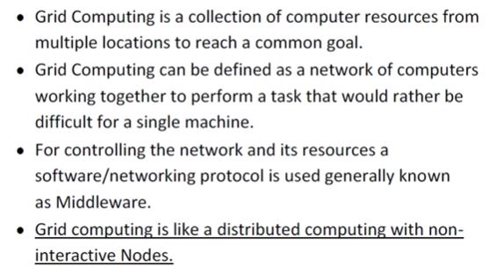

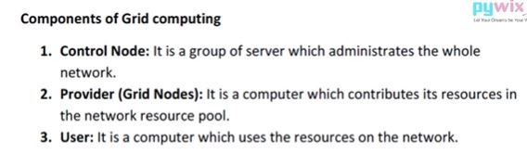
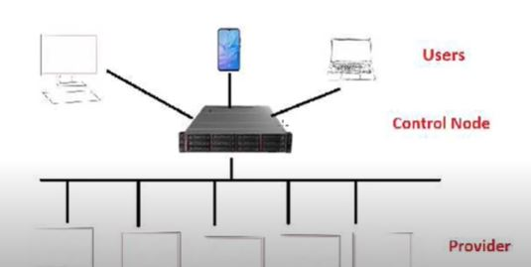
- Cloud Computing: Cloud computing is a computing model that involves delivering computing services over the internet. In this model, computing resources such as processing power, storage, and applications are provided by a third-party provider, and users can access these resources on-demand over the internet. Cloud computing is often used in businesses, where it allows organizations to scale their computing resources up or down as needed, without having to invest in expensive hardware and infrastructure.
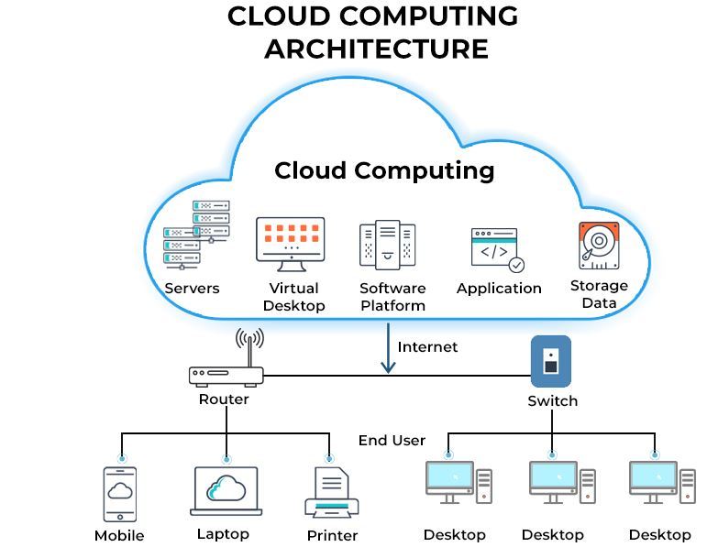
Examples of cloud computing:
- Infrastructure as a Service (IaaS) - Examples include Amazon Web Services (AWS), Microsoft Azure, Google Cloud Platform, and IBM Cloud. These services provide virtualized computing resources such as storage, networking, and computing power.
- Platform as a Service (PaaS) - Examples include Heroku, Google App Engine, and Microsoft Azure App Service. These services provide a platform for developing, deploying, and running applications.
- Software as a Service (SaaS) - Examples include Microsoft Office 365, Salesforce, and Google Apps. These services provide access to software applications that are hosted on the cloud and can be accessed over the internet.
- Cloud storage - Examples include Dropbox, Google Drive, and OneDrive. These services provide a place to store and access data from anywhere with an internet connection.
- Cloud hosting - Examples include Amazon Elastic Compute Cloud (EC2), Microsoft Azure Virtual Machines, and DigitalOcean. These services allow businesses to host their websites or applications on remote servers, providing scalability and flexibility.
- Cloud-based databases - Examples include Amazon Relational Database Service (RDS), Google Cloud SQL, and Microsoft Azure SQL Database. These services provide scalable, managed databases that can be accessed from anywhere with an internet connection.

Comparisons:
- Architecture: Grid computing is based on a decentralized architecture, in which resources are shared among multiple organizations or entities, while cloud computing is based on a centralized architecture, in which resources are provided by a single provider.
- Scalability: Both grid and cloud computing can scale resources up and down as needed, but cloud computing is generally more scalable, as it can quickly provision resources in response to changing demand.
- Resource ownership: In grid computing, the resources are typically owned by the organizations or entities that contribute them, while in cloud computing, the resources are owned by the cloud provider.
- Cost: Grid computing can be more cost-effective than cloud computing for certain workloads, as it relies on shared resources and may not require ongoing subscription fees. However, cloud computing can provide cost savings for organizations that require flexible and scalable resources on an ongoing basis.
- Security: Grid computing can be more challenging to secure, as it involves sharing resources across multiple organizations or entities, while cloud computing can provide stronger security measures, as the cloud provider can control access to resources.

3.Explain utility computing with an example
Utility computing is a model of computing in which computing resources, such as processing power, storage, and software, are made available to users on an as-needed basis, just like the way we pay for utilities like electricity, gas or water. The users pay only for the resources they consume, rather than purchasing and maintaining their own infrastructure.
An example of utility computing is cloud computing services offered by companies like Amazon Web Services (AWS), Microsoft Azure, or Google Cloud Platform. These services provide on-demand access to computing resources such as virtual machines, storage, and databases. Users can scale up or down their usage of these resources as per their requirements, and only pay for what they use.
For instance, a startup may need to host their website or application on a server that can handle a variable amount of traffic. Rather than investing in their own hardware and managing it, they can choose to use cloud computing services and pay only for the resources they need on a pay-as-you-go basis. As the traffic to their website increases, they can easily scale up their usage of computing resources, and as the traffic decreases, they can scale down their usage, which would result in cost savings.
Utility computing allows users to save on costs and resources and to focus on their core business without worrying about the underlying infrastructure.
Utility computing is based on the concept of providing computing resources as a service. It is similar to the way utilities like electricity or water are provided to consumers. Just like you pay for the electricity you consume, in utility computing, users pay for the computing resources they use.
Cloud computing services, such as Amazon Web Services, Microsoft Azure, and Google Cloud Platform, are examples of utility computing. These services provide users with access to computing resources like virtual machines, storage, and databases on a pay-per-use basis. This means that users can quickly scale up or down their computing resources as needed without having to worry about the underlying infrastructure.
Benefits of utility computing:
- Utility computing offers several benefits to users. One of the main benefits is cost savings. Users only pay for the computing resources they use, which eliminates the need for them to invest in expensive hardware and software. This allows them to allocate their resources more effectively and focus on their core business.
- Another benefit of utility computing is scalability. Users can quickly and easily scale up their computing resources as their needs change. For example, a business may experience a surge in traffic to their website during a holiday season. With utility computing, they can quickly increase their computing resources to handle the extra traffic without having to invest in new hardware.
4.Explain briefly about characteristics of cloud computing.
- On-demand self-service: Cloud computing resources can be provisioned and deployed by users on an on-demand basis without requiring human intervention from the cloud service provider.
- Broad network access: Cloud computing resources can be accessed from any device with an internet connection, including desktops, laptops, smartphones, and tablets.
- Resource pooling: Cloud computing resources are shared among multiple users and dynamically assigned based on demand.
- Rapid elasticity: Cloud computing resources can be quickly and easily scaled up or down based on changing demand.
- Measured service: Cloud computing resources usage is monitored and billed based on actual usage, providing users with a pay-per-use model.
- Multi-tenancy: Cloud computing services are designed to allow multiple users to share a common infrastructure and resources while maintaining security and privacy.
- Resilient computing: Cloud computing services are built to be highly available and fault-tolerant, providing users with reliable and resilient computing resources.

